4.29: tricycle and Frank
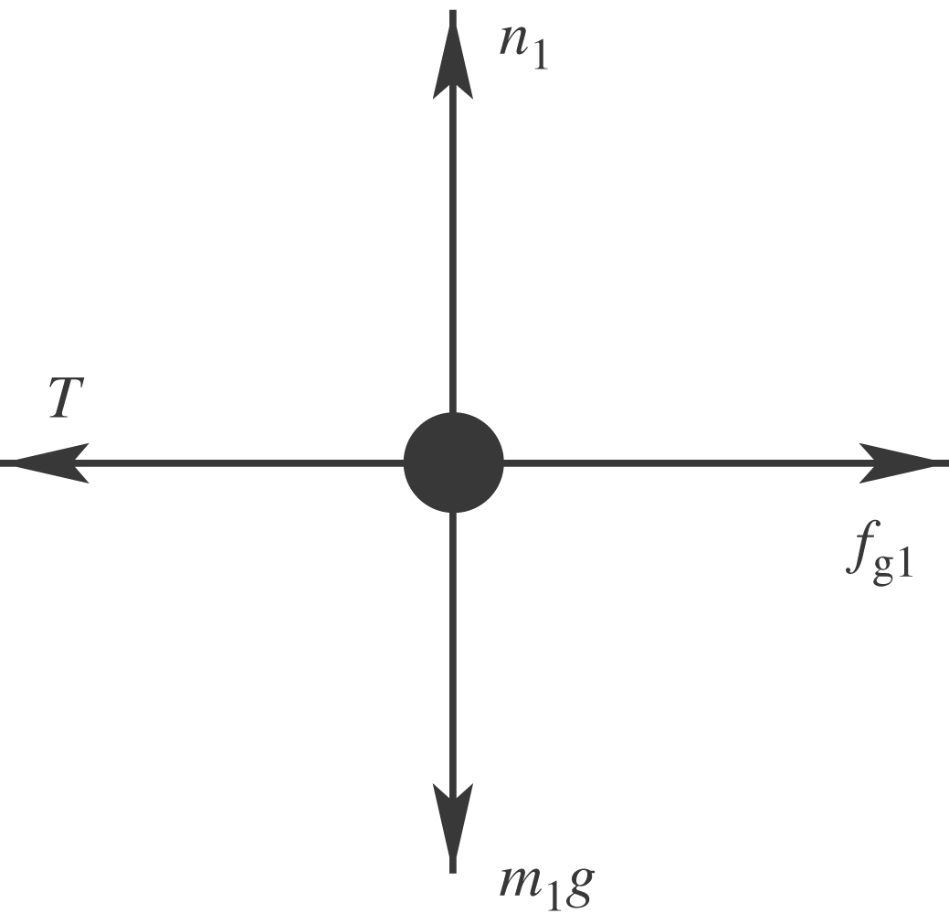

T is the force exerted by the rope and 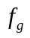 is the force the ground exerts on the tricycle.
spot and the wagon
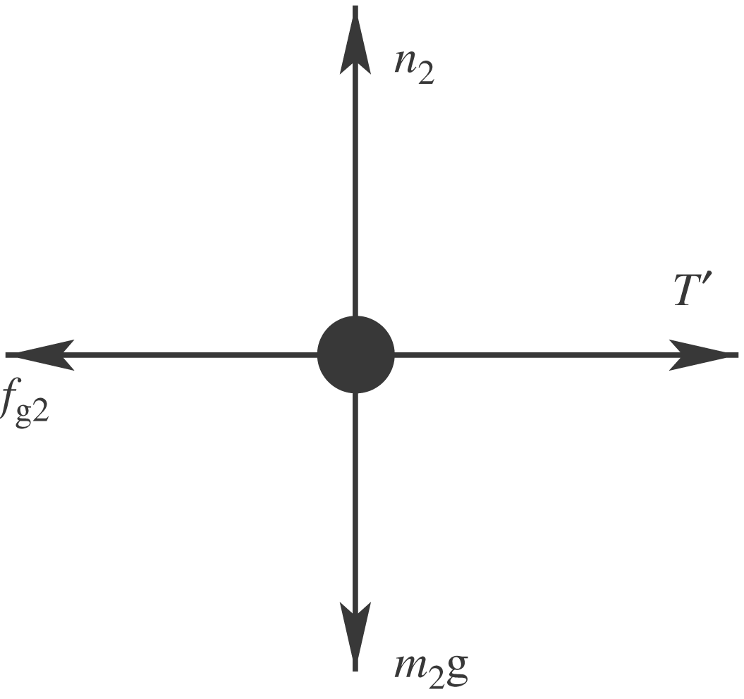
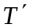 is the force exerted by the rope. T and form a third-law action-reaction pair,
